Kingdom Clean-Up Testing Plan Version 0.1

Team Tersuca

DSU Game Projects Courses 333/444

Executive Producer Dr. Steven K. Graham

Producer Dr. Mark Spanier

Team Lead Dillion Johnson

Project Manager Rachel Groth

QA Testing Lead Carl Petersen

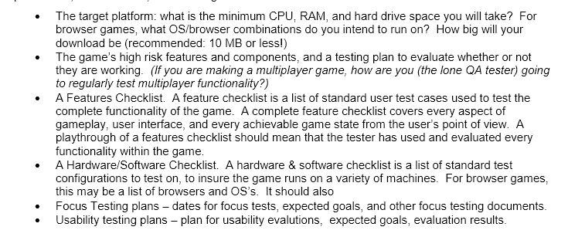

1. The target platform for Kingdom Clean-Up is the Windows PC.

* Optimal operating system will be Windows 10
* The program will be a 32 or 64-bit exe.
* Minimum recommended CPU is the Intel i3-2370M Processor (3M Cache, 2.40 GHz) or equivalent.
* Minimum recommended General Ram is 4 Gigabytes.
* Minimum recommended GPU Ram 1 Gigabyte, Nvidia EVGA 440 or equivalent.
* Estimated Zipped Download size 10 Megabytes.

1. High risk features and Testing plan for each

* Movement in each scene, plan to test if the player can move in each scene and if there is any clipping
* Combat, plan to test if each enemy can be reasonably defeated, by QA lead and players not affiliated with team Tersuca, Game Night, Computer Game Design Club.
* Slime interactions, plan to test each type of slime to see if it has the intended effects.

1. Feature Checklist

* Usable intuitive UI
* Movement
* Combat – Dose Combat work as intended?
* Slime interactions – Do Slime interactions work as intended?
* Fun Factor -- Is Kingdom Clean-Up fun for most people in the target audience?
* Aesthetic integration -- Are the Visual and Auditory assets implemented in a way Appealing to the target audience?

1. Hardware/ Software Checklist

* Base system tests on Fujitsu T725 specs found here --<https://www.cnet.com/products/fujitsu-lifebook-t725-12-5-core-i5-5200u-8-gb-ram-128-gb-ssd-us-xbuyt725004/specs/>

1. Focus testing plan and dates

* 09/04/2018 - First focus test Tuesday,
  + Expected goals
    - Insure movement is working
    - Inspect code for current conventions and readability
* 09/11/2018 - Second focus test Tuesday
  + Expected goals
    - Insure movement is still working
    - Inspect code for current conventions and readability
    - Test basic combat
* 09/18/2018 – Third focus test Tuesday
  + Expected goals
    - Insure movement is still working
    - Inspect code for current conventions and readability
    - Test basic combat
    - Test basic UI

1. Usability testing plans

* Insure that game is playable by wide array of players
* 09/04/2018 Test for color-blind useability/accessibility